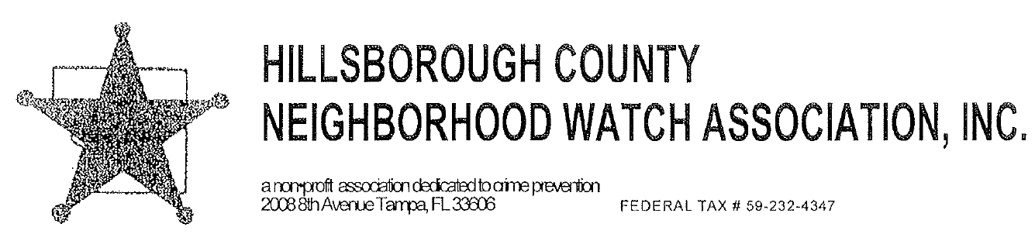

https://www.HCNWA.org
Treasurer: Charlene Molina
Treas.HCNWA@gmail.com
Community Contact Information:

______________________
______________________
______________________
______________________

ANNUAL MEMBERSHIP DUES: YEAR 2021

Please remit fifty cents (.50) per household in your Community

Membership Association name: ____________________________________
Invoice 2021

Number of homes _______ x .50 cents $___________________

Watch Coordinator: ______________________
Street Address: ______________________
City/State/Zip Code: ______________________
E-mail Address: ______________________

PLEASE INCLUDE THIS COMPLETED FORM WITH YOUR DUES TO ENSURE YOUR DUES ARE APPLIED TO THE CORRECT WATCH GROUP AND YOUR CONTACT INFORMATION IS UP-TO-DATE.

Thank you for your immediate attention to this notice. Please include your community name on your check and mail to: HCNWA, P.O. Box 6704, Brandon, FL 33508-6704
15457912v1

